**Pivot Tables for analysis**

1. **Overall, Sales_Profit**: Pivot table showing total sales and profit of different categories & sub-categories. And also, the profit margin of these products (Profit margin = (Profit/Sales) *100). We can filter profit margin by years showing which product’s margin is more or less.

Profit Margin is calculated by creating measure in power query. Data bars, top 1 and bottom 1 in conditional formatting is used.

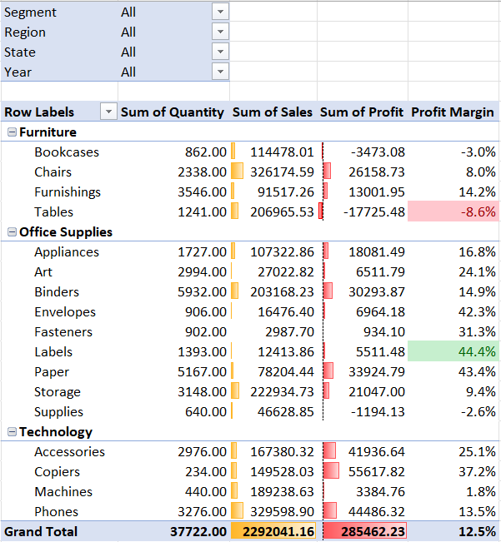

1. **YoY_Sales Comparison**: This pivot table shows sales comparison through out the years. We can analyze which products sales has increased or decreased compared to previous year and by how much percentage. We can filter the results by region, state or segment of customers. Line sparkline is used to show each products trend.

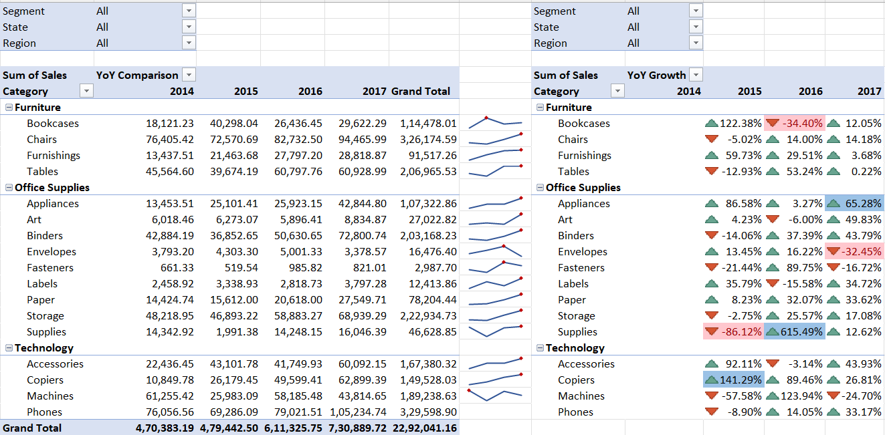

1. **Sales Trend**: This shows quarterly sales trend. We can see that the months of Sep, Nov, Dec have seen more sales.

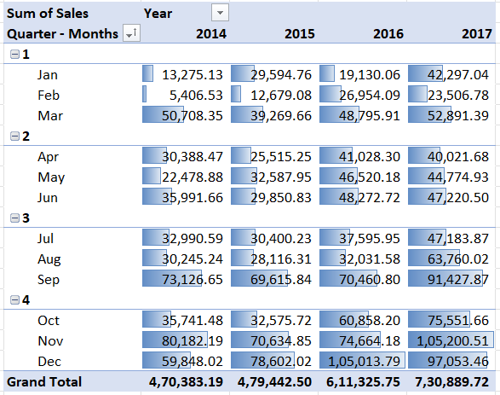

1. **Sales by Region & cities**: This Pivot table shows sales in different regions. Thus, it can be observed that East region has most sales. Also top 5 cities from each region have been taken.

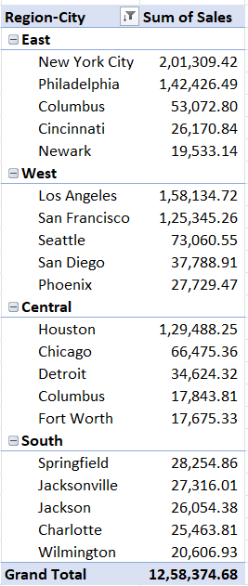

1. **Profit Analysis**: Shows which products are profitable and which are in loss.

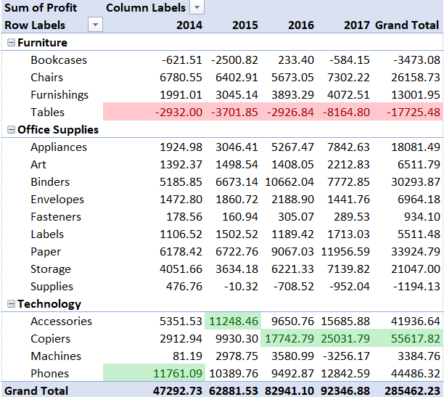

1. **Top 5 Customers**: Shows top 5 customers in terms of sales.

